|  |  |  |  |  |
| --- | --- | --- | --- | --- |
| **National University of Computer and Emerging Sciences, Lahore Campus** | | | | |
| final design | **Course:** | **OOAD** | **Code:** | **CS-309** |
| **Program:** | **BS(Computer Science)** | **Semester:** | **Fall ’18** |
| **Duration:** | **120 minutes** | **Total Marks:** | **40** |
| **Date:** | **Wednesday 31-Oct-2018** | **Weight** | **20** |
| **Section:** | **B and F** | **Page(s):** | **2** |
| **Exam:** | **Lab Mid** |  |  |
| **Instructions/Notes:** | 1. You must ensure that you have made proper submission of your code. No Issues will be entertained later on. 2. Discussion with other students is not allowed. 3. Use of the internet, notes, codes, lab manuals, and flash drives is strictly prohibited. You can though refer to man pages. 4. Plagiarism will result in F grade in lab. 5. No previous code of yours or lab manuals are not allowed. 6. Submission path 7. \\SANDATA\Xeon\Fall 2018\Asad Ullah\OOAD MID SUBMISSION SECTION B AND F\ 8. Students sitting in lab 6 will submit their mid in lab 6 folder in the above path and students sitting in lab 9 will submit in lab 9 folder and so on and so forth. 9. Lab No will be 6, 9 and 10 10. Submit in correct lab folder and in correct question folder. Failure to comply with this instruction will result in a penalty. 11. 10. Submission file or folder should be your roll no and question no L1X-XXXX_QX.cpp | | | |

**Question # 1 (25)**

“Buyable Books ltd” would like to establish an internet-based online bookstore. The customer can interactively select any book from the categories fiction, non-fiction and educational. They can then examine a short description and price of each book, select the ones they want to purchase and proceed to paying for them. To complete payment a form must be filled out with shipping and payment information.

Payment may be by credit card or postal order. The customer may write to a help desk to ask for information. When the order is confirmed, a confirmation email is sent to the customer with details of the order and a reference number. The reference number can be used to check the status of the order on line. Behind the scenes the system must verify the customer’s credentials, request the books from the warehouse, print an invoice and request a delivery to the customer. Implement a function called PrintBookInfo(), This function will display the book price and description. Implement a function called PrintInvoice(), This function will display the order cost and date according to the number of books ordered.You are required to use polymorphic behaviour for implementing PrintBookInfo() function.

Consider a reservation system for an inter-city transportation company that operates buses on

different routes. Each route is determined by a source and destination. On each route different

buses run at different timings. There are two categories of buses that differ in services and

consequently fare. Economy buses provide standard transportation facility and their fare is

computed as a product of the route distance and base rate (fare per km). Luxury buses on the

other hand have a higher base rate, considering reduced seating capacity. In addition, luxury

buses provide different options for refreshments as well as extra luggage, the cost of which can

be added to the fare.

* Draw a class diagram which consists of all the classes in your system their attributes and operations, relationships between the classes, multiplicity specifications, and other model elements that you find appropriate.
* Then perform implementation in JAVA according to your design.
* Write a Driver program to test main functionalities. (Do not create a menu or any extensive test)
* Marks will be deducted if there is a mismatch between design and implementation.
* Use StarUML for this part.
* Make separate .java file for each class.

**Question # 2 (15)**

UML diagram of a system called FAST AUTO MOTORS is given bellow. You need to implement that system in JAVA. You can add method/functions but do not add any attribute in any class and do not change relationship between classes. Size function will print Size of car, and color function will print color of bike.The relationship between Car_ShowRoom and Car and Bike_ShowRoom and Bike is a simple association. For our test program Micro car size is 10, compact Car size is 15 and SubCompact Car size is 20. A driver program is also given, your code should run that driver program.

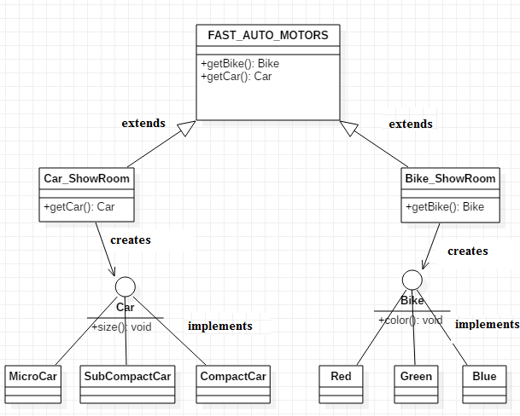

|  |  |
| --- | --- |
| **Driver.java**  public class Driver  {  public static void main(String[] args)  {  FAST_AUTO_MOTORS m = new Car_ShowRoom();  Car car = m.getCar("Micro Car"); //This will print “ you ordered a Micro car in constructor.  car.size();  m=new Bike_ShowRoom();  Bike bike = m.getBike("Blue"); //This will print “ you ordered a blue bike in constructor.  bike.color();  car = m.getCar("Compact Car");  bike = m.getBike("Red");  car.size();  bike.color();  }  } | Sample Output:  You ordered a Micro car  Micro car size is 10  You ordered a blue bike  Bike color is blue  You ordered a Compact car  You ordered a red bike  Compact car size is 15  Bike color is red |